Crime per City data frame is where we are looking at the total crime per city and where it ranks against each other. Below you can see in the table the 10 cities we have chosen for our project and the categories inside the table which are “states”, “population 2024”, “total_crime” (the main focus of this section), and “total crime score”. The city rankings go from 1 to 10. 1 being the highest crime rated city and 10 being the lowest crime rated city.

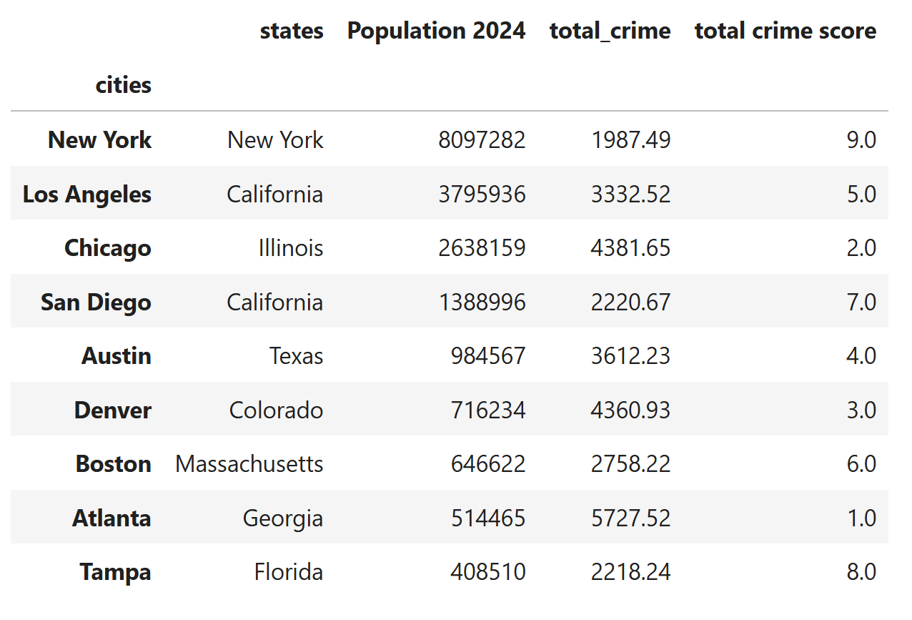

Looking at the data frame table we collected above we can that:

* Atlanta is ranked at number 1 being the worst crime rated city at 5,727.52 total crimes per 514,465 total population.
* At bottom we have New York ranked number 10 as the lowest crime rated city at 1,987.49 total crimes per 8.097 million total population.

A better representation of this data frame is the bar graph below:

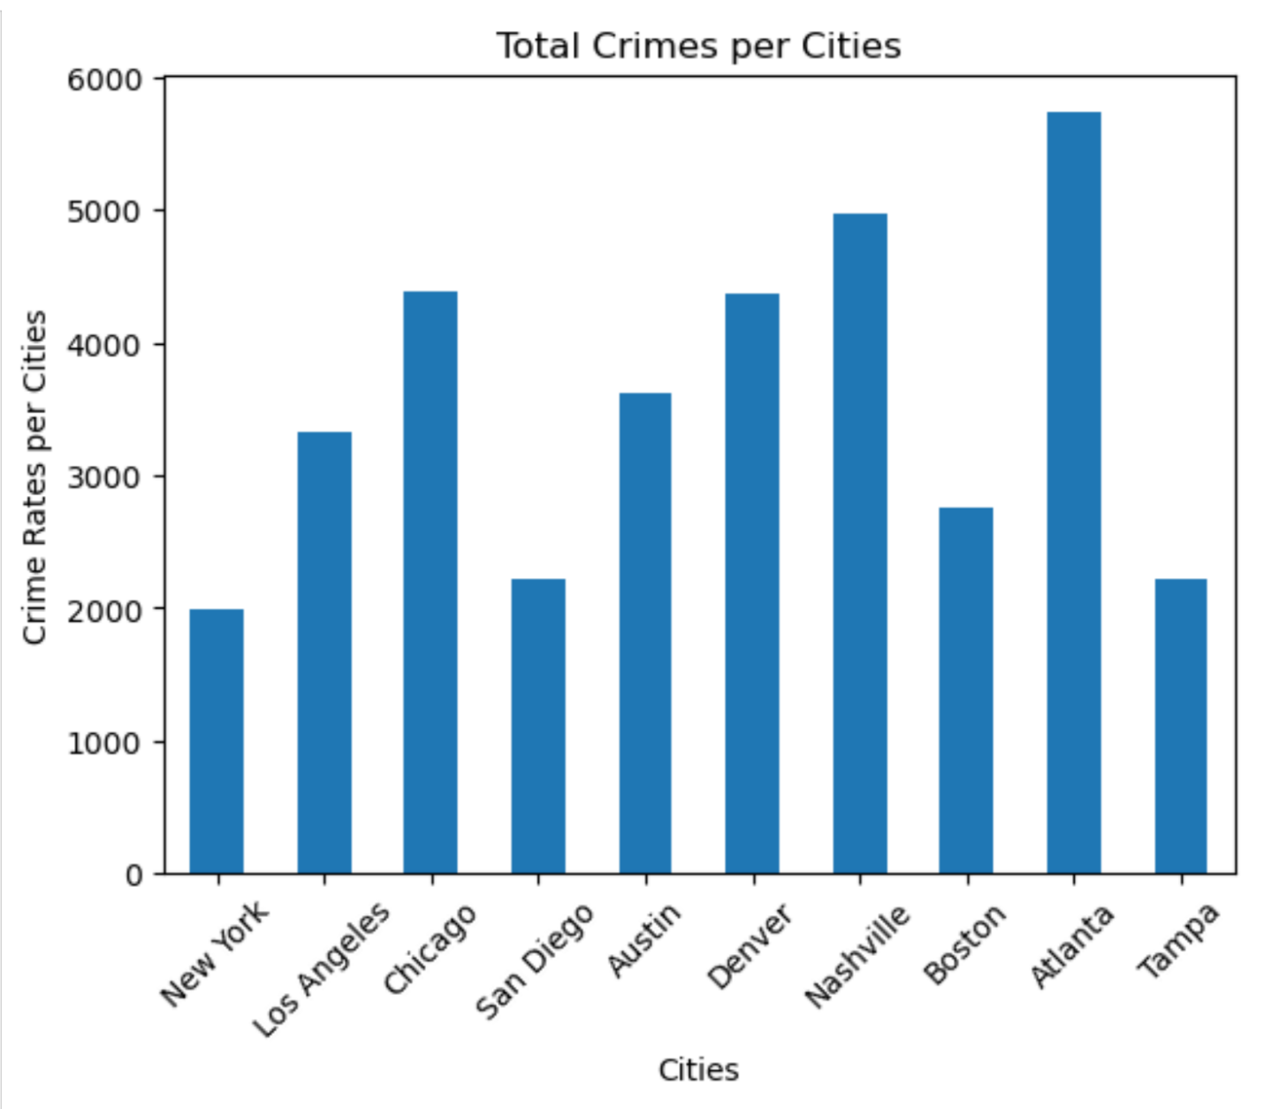

What we can take away from the data frame, the table, bar graph, and the numbers is:

* New York is the safest city out of the 10 cities we have chosen for this project while also having the largest population.
* Meanwhile can see that Atlanta is the most dangerous city from the 10 cities we have chosen while being second smallest city in table.

When looking back at everything this puts things into perspective:

* Most people would think that New York, Los Angeles, or Chicago would be either number 1 or if not in the top 3.
* While Chicago was true, both New York and Los Angeles were not ranked in the top 3.

We should also look at the data for population to crime rate ratio. When comparing the data between population and total_crime we can see that:

* Smaller cities like Atlanta and Tampa are going to have a higher total crime per population count.
* This would be based on per person and crime.
* On the other hand, you have New York and Los Angeles who have a higher population to their total crimes.
* Thus, this shows that the population is greater than the crimes happening in those cities.